**Utilization Calculations**

Current Rig Activity Forecast:

* Primary Job Count – Primary jobs per day. Job will be allocated to a day dictated by end date/time. If a job starts on Aug 1 and ends on Aug 2, Aug 2 will get the job count. Aug 1 will not receive any job count.
  + Primary jobs can be mapped from job type (master data)
* Remedial/Miscellaneous Job Count – Remedial/Misc jobs per day. Job will be allocated to a day dictated by end date/time. If a job starts on Aug 1 and ends on Aug 2, Aug 2 will get the job count. Aug 1 will not receive any job count.
  + Is this remedial/misc or anything not primary - YES
    - Infrastructure – Need to add a line for infrastructure
    - This work usually does not have a rig
  + Remedial jobs can be mapped from job type (master data)
* Total Job Count = Primary job count + remedial job count + Infrastructure job count
* Additional Pump Demand/Job – not required if we have a truck count per job
  + These are 2 truck jobs
  + Don’t currently have a truck count per job
    - Import pumper count from program
    - Confirm/Enter # of pumper when “Add new job”
  + Pipeline, Batchmixer, Foam etc have multiple crew
    - Confirm/Enter # of truck count in the “Add Job” function
* Units on Standby/Day Rate – NOT required as a line
  + - These will be jobs on the board when required
* Active Pump Count - ***Need Available active pump count***
  + Used by fleet management not operations
  + **Operations want the line removed**
* Pump Utilization = (active pump count + Units on standby/day rate + additional pump demand/job) / total job count
  + **Change this to hourly utilization – calculation below**
* Twin Pumper - ***Need Available manned pump count***
* Single Pumper - ***Need Available manned pump count***
* Total Manned Pump Count – Twin pumper + single pumper
* Crew utilization = (Total job count + Additional pump demand/job + units on standby/day rate) / Total manned pump count
  + **Change this to hourly utilization – calculation below**
  + **Include job time, travel time, pre trip, post job etc**
    - **Future phase to add travel time, pretrip and post trip to the start and end of a job in a different shade of color and use in the utilization calculations.**
* Active Rigs – Total rigs Sanjel is working for (rig board data)

Active pump count, twin pumper and single pumper is currently tracked in the Rig Activity forecast sheet as follows:

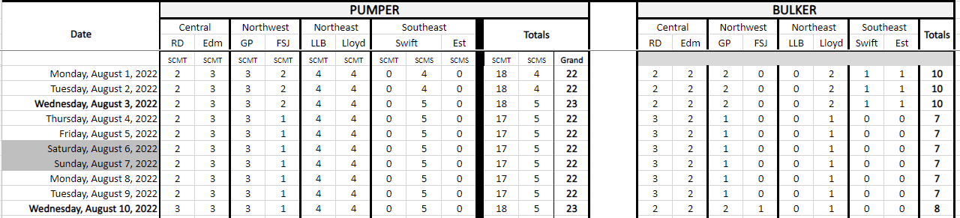

Each district manager, dispatcher, or ops manager will maintain this sheet daily.

**Propose that we develop a tool to help manage this sheet:**

There are 3 pumper categories:

* Active units – from AX
  + District is in AX from assigned district
* Active units, but down for maintenance – from eMaintain / may need to manage (tool below will manage for now)
* Active units, manned – Need tool to manage

To manage the Manned and Active trucks, create a tool that remains similar to the current excel spreadsheet entry – create another sheet for data entry with access by all the managers to modify:

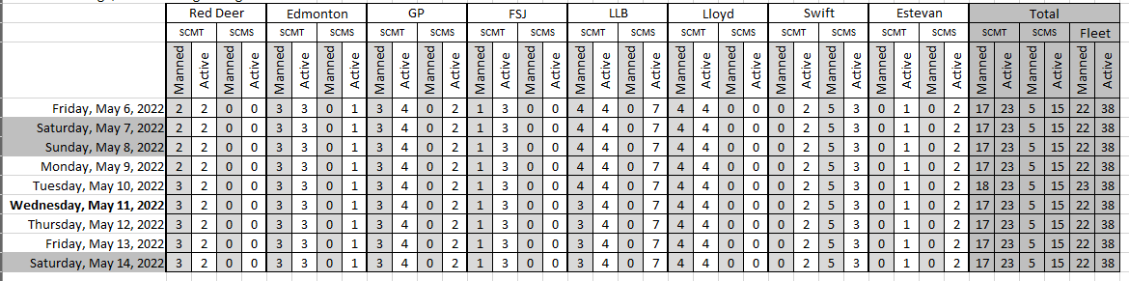

* Total section is all sums
* Manned / Active are entered by management
* Truck Types
  + SCMT – twin trucks
  + SCMS – single trucks
* Active and manned
  + per truck type
  + per district
* Selection by “Manned” or “Active”
  + Select “Manned” and have all the manned entries for all districts
  + Select “Active” and have all the manned entries for all districts
* Ability to scroll through all dates
* Ability to select a date showing 2 weeks
* Ability to enter data up to 3 months in the future
  + Active units remain fairly static

Hourly Utilization:

* #hrs worked in a day / total hrs available in a day
* Use for both people and equipment
  + total hrs available in a day for people = 16
  + total hrs available in a day for equipment = 24
* Can be both with and without travel
* Have a max of 100% per person.

Capacity Utilization:

* Total of People Hourly utilization / total # of available people
* Total of pumpers Hourly utilization / total # of available manned pumpers